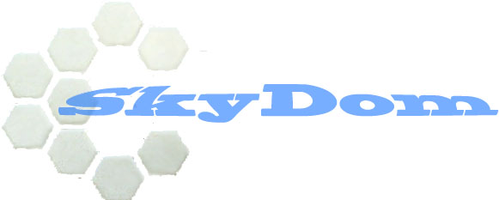

The Sky Isn’t The Limit Anymore

Contents
Introduction
General Information
Physical Appreance
Research
Financing
Conclusion

Science makes advancements every day, but the public doesn’t realize it. We are still using technology based from 70’s and we don’t realize that they are inefficient and impractical for the 21st century. SkyDom is dedicated to cross the bridge from the labs to the public so we can advance society as a whole. We are a research and development company not after money but the sheer enjoyment to see our products reach the market. We are going to bring back the concept of creativity in the world. Everyone will benefit from our products because we have no main limitation in our category of products. Our company is made from the background of the society and for the society; we are just putting a name to the group.

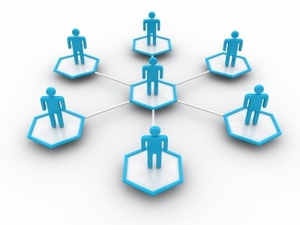

Introduction

Progression is made by the advancement of the private and public sectors. Science makes advancements on daily bases but we do not take advantage of these discoveries until years later. Tesla’s ideas are now taking effect in the public at mass. His discoveries were made decades ago. Here at Skydom, we are taking modern discoveries and incorporating them into the public. Started off in Florida, homemade, not for profit, new age projects and innovative ideas. We will rent out rooms for individuals for private purposes and experiments.

General Information
We have three main focuses here at SkyDom, and that is to imagine, build and release. Our area of expertise would be diverse but mainly focusing on light technology. We want to be the first to experiment with light and the way we can manipulate it. Light is a form of energy that travels freely through space, it is an electromagnetic wave, it is energy. We can harvest this energy at 35% with a solar cell but that is converting it to another form of energy called electrical energy. What if we made products based off of light, what if we can rely on something that is presented to us on average of twelve hours a day. This is where SkyDom takes it’s step in, we are the ones who will research this among other interesting phenomenons.

Goals:
-Innovate
-Design
-Build
-Test

Aims
-Research new designs with the most innovative materials.
-Release a manufacturing process to get the product to the public
-Test and finding the breaking point of materials

Mission
-To bring a useable product at mass production for the consumer market.
-Make a research facility to test new materials.
-Custom made exotic material to meet our customer needs

Why would we succeed:
. This kind of business will take off because of all the strives for science advancements and learning but there are no practical place that these scientist can work and do what they love to do, build, discover and explore. It use to be that we could do these things in our backyard but we eventually came to a point that to make further advancements we need more expensive and delicate instruments and tools that the general public can not afford.

Physical appearance

Building

Market
The market of this type of business is really small and that is our goal, to make the public have a business to go to for exotic material and products to meet their needs.

Competitor
Right now there are no competitors that are running anything similar around this area. What we do is offer a place for scientist to work without a license and have rules like they do at most colleges and labs around the area. The only competition would be maybe a university near-by but the only treat from them would be if they offer open labs day in and out. Most of their labs are closed certain times and you cannot have a long testing that can be conducted. This limitation we would not put on to our customers.

Research, Trade Show
2 | NOAA  4 | NASA  6 | ScienceDaily | 14 | Space  10 | ScienceBlogs  11 | PhysOrg

13 | LiveScience  12 | NewScientist | 14 | Space

Research:
Our research is going to be conducted over the Internet, in a trusted network. Most of the physical experiment is going to be conducted at a lab where all the variables are controlled. This will limit the factors that would be present in a normal condition.

Facility
The facility is going to be painted white anti-bacterial surfaces. There is also going to be glass panels separating the different rooms, if anything might be going on. There will be 4 rooms for biology experiment, 4 rooms for physical experiments, 2 rooms for computer, and programming.

5-biology room: | 5 rooms for physical:
- Bacterial  - Viral  - Bioelectricity  - 2-Neurology  - Psychology  - Neurochemistry | - 2 Engines  - Flight (lift)  - Car  - Quantum  - Material  - Electricity  - Space
2 -computer, and programming rooms: | 2 Supply Room
- Multiple system-super computer  - Programming and coding | - Chemical  - Equipment

Equipment | Supplies:
- Electron microscope  - Microscope  - Super Computer  - Computer  - Centrifuge  - EEG, EKG, ECG  - Cryogenic Freezer  - Telescope  - Super Critical Dryer  - Fume vent  - Glassware  - Bunsen burner  - Laser  - Micrometer  - power supply  - high voltage converter | - NO3  - H2  - O2  - Wires  - Paper  - Platinum Catalyst  - TMOS  - TEOS  - Methane  - CO2  - Xenon

Financing
Financing would come from renting out room and equipment to the public for a fixed rate. When renting out rooms they would be on either contract:
Weekly
Monthly
Bi-annual
Annual
This will insure, that the consumer will choose a more convenient schedule for me, and I’ll make deals that the more day that they buy the cheaper it becomes. I will run monthly deals and have ways to help out when they need. Financing will mainly come from this option. We will try to get donations and grants and if a business want to buy out a project, Skydom will be the middleman to connect the two groups.
As part of the contracts any and all discoveries made will be owned by us but entitled to the individual. We have right to sell the discoveries made, making the patent under our names but the individual will be the one who “invented” it. This can be a good thing to the individual being he might have invented something new but have no use for it, but it might be useful to us.

Conclusion:

Threats of my business includes law suits that may arise from claiming the idea to be all thiers. But this can be settled with the contract that the subject had signed. The threat of having someone doing something illegal is another worry in our company, we will try to stop illegal and unethical testing of any kind, this included skeptical projects like genetics and experiments on live animals.
Weaknesses, there is always the issue of if the business would have a good turn out, it seems like it would because we are all curious to test one of our ideas but do not have the time or the equiptments to test it. The starting of the business is going to be the most difficult part, the best way for advertisement to make money is by word of mouth since we would be one of the only company that offer this type of service to the mere public.
The strenght of a business like this comes from the fact that many people are loosing their jobs, and may have projects that think that they might be able to make and sell. The thing is that these people do not know how to get around the legal steps of getting their ideas out there. Another one of our streghts is that the we would have control over your research making it more of our project with the help of you. Schools and businesses are promoting science and technology so this gives a high market of people going after this field without a job being filled, and with the recent lay off of NASA employees they may have ideas that need to be tested.
Our business have the oprotunity to become very large due to the fact of being the only one offering this. We will have a forum to know about upcoming technology and research, this opportunity gives me and edge over my competition by having the knowledge the possibilities that research is finding.

